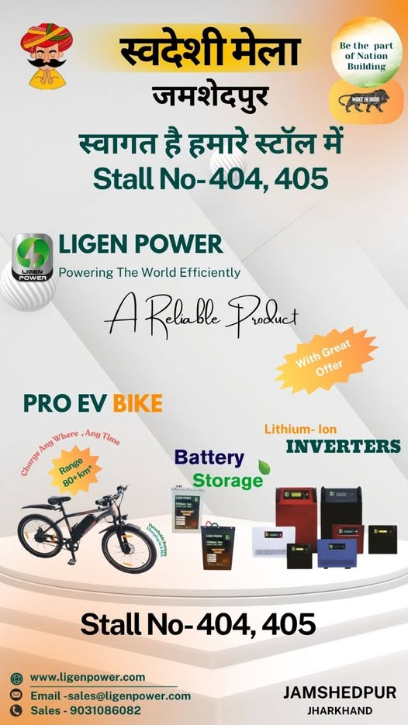
Ligen Power at Swadeshi Mela, Jamshedpur – Visit Us at Stall No. 404 & 405!
Ligen Power is delighted to participate in the Swadeshi Mela, Jamshedpur, a grand event celebrating India’s spirit of innovation, sustainability, and self-reliance.
We invite everyone to visit our Stall No. 404 & 405 and explore our complete range of smart, efficient, and eco-friendly energy products.
Powering the World Efficiently with Ligen Power
At Ligen Power, we believe in creating a sustainable energy future through innovation and reliability. Our products are designed to deliver performance, safety, and long-term savings for homes, businesses, and electric mobility.
Here’s what you can explore at our stall:
Lithium-Ion Inverters
Experience uninterrupted power with our next-generation lithium-ion inverters, known for their fast charging, high efficiency, and long life. Ideal for residential, commercial, and industrial applications.
Battery Storage Systems
Our advanced battery storage solutions are engineered to store clean energy efficiently. They ensure continuous power supply and are perfect for solar setups, EV charging, and home energy systems.
Pro EV Bike
Discover the Ligen Power Pro EV Bike – built for performance and sustainability.
Range: 80+ km
Charge Anytime, Anywhere
Eco-friendly & Cost-efficient
Ride into the future with clean energy mobility!
E-Cycle and EV Charging Solutions
Go green with our electric bicycles and EV charging equipment that make sustainable travel convenient and affordable.
Solar-Ready Solutions
Our inverters and batteries are compatible with solar systems, enabling you to harness the power of the sun and reduce electricity bills.

Exclusive Offers at the Mela
Visit our stall to enjoy special discounts, product demos, and expert consultations. Our team will guide you in choosing the right power solution for your home, office, or business.

